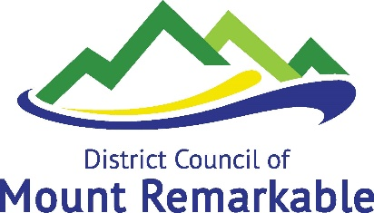

Community Plant Sale
Order Form

Name:
Address:
Contact Number:

Please indicate the type and number of species below: (maximum of 25 trees per person)
Tree Species | Quantity  ($1 each)
Acacia brachybotrya (Grey Mulga)
Acacia iteaphylla (Flinders Range Wattle) | -
Acacia ligulata (Umbrella Bush)
Acacia notabilis (Notable Wattle) | -
Dodonaea viscosa angustissima (Narrow Leaved Hop-Bush) | -
Eucalyptus porosa (Mallee Box)
Eucalyptus socialis (Summer Red Mallee)
Eucalyptus camaldulensis obtusa (Northern River Red Gum)
Eucalyptus gracilis (Yorrell)
Melaleuca lanceolata (Dryland Tea Tree) | -
 | Total

Will you be planting these on Council owned land? Please circle Yes / No
Please briefly describe below where you may intend to plant them

☐ By ticking this check box, I acknowledge that I will abide by Councils Tree Policy (attached to this form) if I will plant trees on Council land, and I am aware that I must pay for the trees in full via the Council Office or over phone, prior to collection.

Signed
Date

